Section 1 Tables

4.1 Roles and Boundaries
Organizations and humans can assume different types of pre-defined roles depending on how they relate to and/or interact with a cloud and its hosted IT resources. Each of the upcoming roles participates in and carries out responsibilities in relation to cloud-based activity. The following sections define these roles and identify their main interactions.

Cloud Provider
The organization that provides cloud-based IT resources is the cloud provider. When assuming the role of cloud provider, an organization is responsible for making cloud services available to cloud consumers, as per agreed upon SLA guarantees. The cloud provider is further tasked with any required management and administrative duties to ensure the on-going operation of the overall cloud infrastructure.
Cloud providers normally own the IT resources that are made available for lease by cloud consumers; however, some cloud providers also “resell” IT resources leased from other cloud providers.

Cloud Consumer
A cloud consumer is an organization (or a human) that has a formal contract or arrangement with a cloud provider to use IT resources made available by the cloud provider. Specifically, the cloud consumer uses a cloud service consumer to access a cloud service (Figure 4.1).
The figures in this book do not always explicitly label symbols as “cloud consumers.” Instead, it is generally implied that organizations or humans shown remotely accessing cloud-based IT resources are considered cloud consumers.
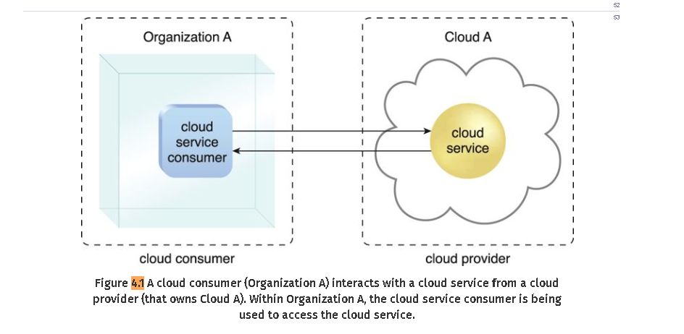

NOTE
When depicting interaction scenarios between cloud-based IT resources and consumer organizations, there are no strict rules as to how the terms “cloud service consumer” and “cloud consumer” are used in this book. The former is usually used to label software programs or applications that programmatically interface with a cloud service’s technical contract or API. The latter term is more broad in that it can be used to label an organization, an individual accessing a user-interface, or a software program that assumes the role of cloud consumer when interacting with a cloud, a cloud-based IT resource, or a cloud provider. The broad applicability of the “cloud consumer” term is intentional as it allows it to be used in figures that explore different types of consumer-provider relationships within different technical and business contexts.

Cloud Service Owner
The person or organization that legally owns a cloud service is called a cloud service owner. The cloud service owner can be the cloud consume or the cloud provider that owns the cloud within which the cloud service resides.
For example, either the cloud consumer of Cloud X or the cloud provider of Cloud X could own Cloud Service A (Figures 4.2 and 4.3).
Note that a cloud consumer that owns a cloud service hosted by a third-party cloud does not necessarily need to be the user (or consumer) of the cloud service. Several cloud consumer organizations develop and deploy cloud services in clouds owned by other parties for the purpose of making the cloud services available to the general public.
The reason a cloud service owner is not called a cloud resource owner is because the cloud service owner role only applies to cloud services (which, as explained in Chapter 3, are externally accessible IT resources that reside in a cloud).
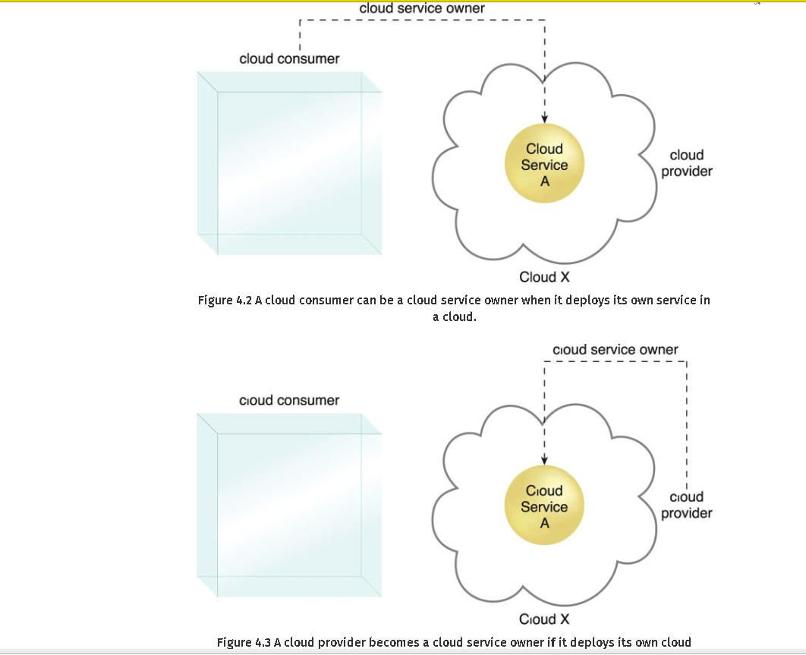

Section 3

Polling Agent
A polling agent is a processing module that collects cloud service usage data by polling IT resources. This type of cloud service monitor is commonly used to periodically monitor IT resource status, such as uptime and downtime (Figure 7.14).
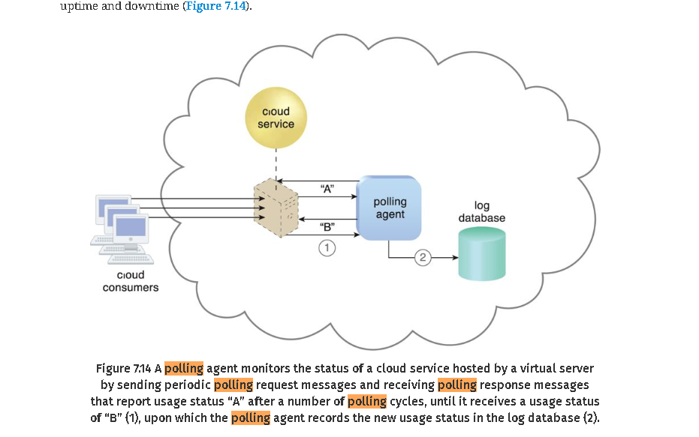

Figure 7.14 A polling agent monitors the status of a cloud service hosted by a virtual server by sending periodic polling request messages and receiving polling response messages that report usage status “A” after a number of polling cycles, until it receives a usage status of “B” (1), upon which the polling agent records the new usage status in the log database (2)

CASE STUDY EXAMPLE
The standard SLA for virtual servers in DTGOV’s leasing agreements defines a minimum IT resource availability of 99.95%, which is tracked using two SLA monitors: one based on a polling agent and the other based on a regular monitoring agent implementation.
SLA Monitor Polling Agent
DTGOV’s polling SLA monitor runs in the external perimeter network to detect physical server timeouts. It is able to identify data center network, hardware, and software failures (with minute-granularity) that result in physical server non-responsiveness. Three consecutive timeouts of 20-second polling periods are required to declare IT resource unavailability.
Three types of events are generated:
- • PS_Timeout – the physical server polling has timed out
- • PS_Unreachable – the physical server polling has consecutively timed out three times
- • PS_Reachable – the previously unavailable physical server becomes responsive to polling again
SLA Monitoring Agent
The VIM’s event-driven API implements the SLA monitor as a monitoring agent to generate the following three events:
- • VM_Unreachable – the VIM cannot reach the VM
- • VM Failure – the VM has failed and is unavailable
- • VM_Reachable – the VM is reachable
The events generated by the polling agent have timestamps that are logged into an SLA event log database and used by the SLA management system to calculate IT resource availability. Complex rules are used to correlate events from different polling SLA monitors and the affected virtual servers, and to discard any false positives for periods of unavailability.
Figures 8.8 and 8.9 show the steps taken by SLA monitors during a data center network failure and recovery.
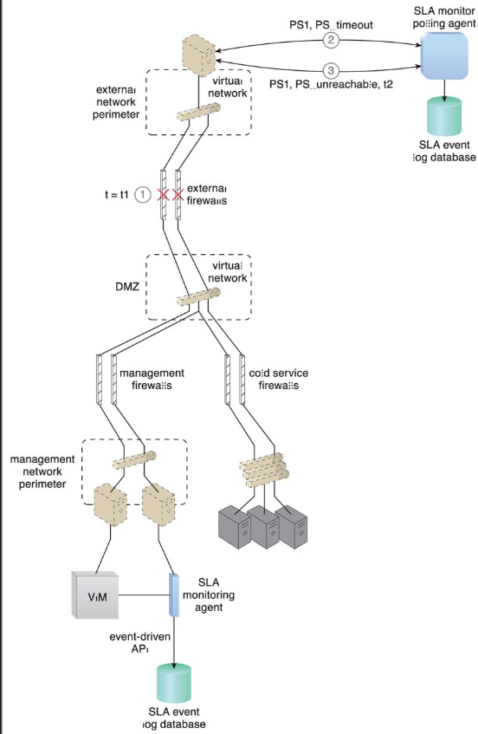
Figure 8.8 At timestamp = t1, a firewall cluster has failed and all of the IT resources in the data center become unavailable (1). The SLA monitor polling agent stops receiving responses from physical servers and starts to issue PS_timeout events (2). The SLA monitor polling agent starts issuing PS_unreachable events after three successive PS_timeout events. The timestamp is now t2 (3).
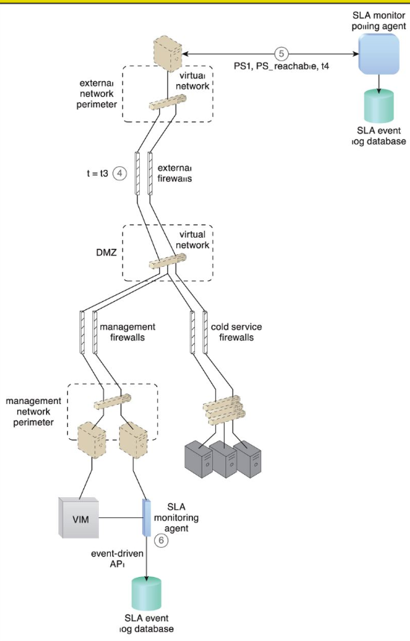
Figure 8.9 The IT resource becomes operational at timestamp = t3 (4). The SLA monitor polling agent receives responses from the physical servers and issues PS_reachable events. The timestamp is now t4 (5). The SLA monitoring agent did not detect any unavailability since the communication between the VIM platform and physical servers was not affected by the failure (6).
The SLA management system uses the information stored in the log database to calculate the period of unavailability as t4 – t3, which affected all of the virtual servers in the data center.
Figures 8.10 and 8.11 illustrate the steps that are taken by the SLA monitors during the failure and subsequent recovery of a physical server that is hosting three virtual servers (VM1, VM2, VM3).
